GRADES AND GRADING PERIODS

Teachers are expected to update grades in PowerTeacher weekly. Schools will issue report cards and interim reports according to the division calendar. Any change or modification to the grading policy requires prior approval by the Principal and Assistant Superintendent of Instruction. If a parent would like to contest a grade, the time is limited to a two-week window beyond the issuance date of the report card. The appeal needs to be submitted to the principal in writing.

Elementary School Grading Procedures
In order to create a more consistent communication tool and give students and their parents a clear vision of what is required to succeed in school, a standards-based report card is utilized for elementary students. The criteria correlate to the Virginia Department of Education Standards of Learning Achievement Record requirements. Student performance shall be based on the percentage of time the student is able to perform the standard based on teacher observation and evaluation. The learner quality standards shall also use mastery indicators. Parents receive information on exactly how well students are learning the curriculum and what is expected of them to succeed.

Kindergarten through Grade 2 teachers shall use mastery indicators for each Standard of Learning (SOL) taught using the criteria listed below:
Grades | Indicators of Mastery | Criteria | Equivalent  Grading Scale
K - 2 | O= Outstanding  S= Satisfactory N=Needs Improvement U=Unsatisfactory | Exceeds the standard  Meets the standard (at least 80% of the time)  Partially meets the standard Inadequate or no understanding of the standard | 90 to 100%  80 to 89%  70 to 79%  69% and below

Grade 3 through Grade 5 and Westside Elementary Grade 6 teachers shall use grades and mastery indicators for each Standard of Learning (SOL) taught using the criteria listed below:
Grades | Indicators of Mastery | Criteria | Grading Scale
3-6* | O= Outstanding | Exceeds the standard | A = 93-100
 | S= Satisfactory | Meets the standard (at least 80% | A- = 90-92
 | N=Needs Improvement | of the time) | B+ = 87-89
 | U=Unsatisfactory | Partially meets the standard | B = 83-86
 |  | Inadequate or no | B- = 80-82
 |  | understanding of the standard | C+ = 77-79
 |  |  | C = 73-76
 |  |  | C- = 70-72
 |  |  | D = 65-69
 |  |  | F = 64 or
 |  |  | Below

Using the grading scale, letter grades shall be calculated so that all category averages count equally. Averages shall be calculated as follows:
- Test/Project
- Quiz
- Classwork

An example of a letter grade calculation follows:

Test/Project | Quiz | Classwork
84 | 80 | 94
92 | 81 | 92
83 | 94 | 100
 | 100 | 86
 |  | 90
 |  | 97
Average =  (84+92+83)/3 | Average =  (80+81+94+100)/4 | Average =  (94+92+100+86+90+97)/6

Nine Weeks Grade = average of all three categories = 89.4 = B+

For each nine weeks, students in a traditional classroom setting will receive at least the minimum number of grades per category as described below:

Tests/Projects-- Three
Quizzes-- Four
Classwork-- Six

Middle and High School
Letter  Grade | Score  Ranges | Description of Performance
A | 93-100 | Does outstanding class work, shows superior initiative in completing learning activities,  and demonstrates high achievement
A- | 90-92
B+ | 87-89 | Does good class work, shows above average initiative in completing learning activities,  and demonstrates above average achievement
B | 83-86
B- | 80-82
C+ | 77-79 | Does average class work, shows average initiative in completing learning activities, and  demonstrates average achievement
C | 73-76
C- | 70-72
D | 65-69 | Does below average or incomplete class work, shows some initiative in completing  learning activities, and demonstrates poor achievement
F | 64 and below | Incomplete class work, shows little initiative in completing learning activities, and  demonstrates unacceptable achievement
The grading scale for the Isle of Wight County Schools consists of sections for letter grades, score ranges, and descriptions of performance. The grading scale follows:

Middle School Grading Procedures
Middle school teachers are expected to provide a final letter grade in academic subjects and exploratories taught during the nine weeks grading period. Middle school students in a traditional classroom setting will receive at least thirteen grades (three tests/projects/essays, five quizzes/labs/presentations, and 5 classwork/learning activities/reflections) in PowerTeacher for each student in every course taught during the nine weeks grading period.

Grades will be calculated based on the categories and weighted values below:

Category | Weighted Value
Tests/Projects/Essays | 33.333%
Quizzes/Labs/Presentations | 33.333%
Classwork/Learning Activities/Reflections | 33.333%

Students will be required to complete a culminating activity for each course.

Semester and final yearlong grades shall be given in middle school. The two quarter nine weeks grades shall be averaged together to determine the final grade in a semester grade courses. The four nine weeks two semester grades shall be averaged to determine the final grade for yearlong grade courses.

Below is an example of a letter grade calculation follows:

Tests/Projects/Essays | Quizzes/Labs/Presentations | Classwork/Learning Activities/Reflections
87  90  75  88  89  92 | 77  89  93  100 |  | 99  86  77  65
Average: 87 | Average : 90 | Average: 82

Nine weeks grade =

Quarter Nine weeks grade = (87 x .33333) + (90 x .33333) + (82 x .33333) = 86 = B

Letter grades shall be used to record student achievement on report cards. Letter grades shall be used to identify honor roll students. Middle School students who successfully complete a high school credit bearing course, will earn the standard unit of credit required for graduation. The high school credit bearing course will receive a numeric grade on the report card and the high school transcript. State standards require that when students below the ninth grade successfully complete courses offered for credit in grades 9 through 12, credit shall be counted toward meeting the standard units required for graduation provided the courses are equivalent in content and academic rigor as those courses offered at the secondary level. Therefore, these high school credit bearing courses will use the categories and weighted values established below:

Category Weighted Value

Tests/Culminating Projects 45%
Classwork/Labs/Quizzes/Essays/Projects | 25%
Homework | 10%
Exam | 20%

High School Grading Procedures
High school students in traditional classroom settings will receive at least two grades per category every four and one-half weeks.

A student’s high school grade shall consist of an 80% / 20% split. Learning activities shall count 80% while the mid-term/final exam shall count 20%. The learning activities are included in the different types of courses below.

Grades will be calculated based on the categories and weighted values below:

All Courses (except for the courses listed below)

CategoryLearning Activities Weighted Value
Test/Culminating Projects 55%
Classwork/Lab/Quiz/Essay/Project 30%
Homework 15%

AP and Honors Courses
CategoryLearning Activities Weighted Value
Test/Culminating Projects 60%
Classwork/Lab/Quiz/Essay/Project 30%
Homework 10%

Career and Technical Education (CTE) Courses
CategoryLearning Activities Weighted Value
Test/Project 40%
Classwork/Journal/Lab 30%
Quiz/Sub-unit 20%
Homework 10%

Foreign Language Courses
CategoryLearning Activities Weighted Value Test/Project 45% Quiz/Language Skills 30% Homework/Classwork 25%

Grades for the first half and the second half of a semester or yearlong course are determined by averaging the nine weeks grade(s) and the examination grade. The nine weeks grade(s) shall count 80% and the examination grade shall count 20%. Learning activities shall count 100% of the nine weeks or semester grade in the event of exam exemption (see IKG). The grades for the first half and second half of the course are averaged to determine the final grade. Numerical grades shall be used to report student achievement.

High School Grading Procedures

There are three main categories for determining a student’s nine weeks, or quarter average.

Mastery—50% (may include tests, projects and midterm assessments)
Growth— 40% (may include quiz and classwork grades)
Practice—10% (may include homework and class participation grades)

There will also be a Final Activity category in PowerSchool that will be weighted 15% of a student’s overall final grade.

Semester-Long Courses:

For semester-long courses, a student’s final grade will be calculated using the following procedure:
- Each 9 weeks, or Quarter, will only be based on the three categories listed above (Mastery, Growth, Practice).
- For the Final course Grade, the Final Activity will count 15% and the two 9 weeks grades combined will count the remaining 85%.

The calculation in PowerSchool for a high school Semester 1 or Semester 2 course will look as follows:

Quarter 1 or Quarter 3
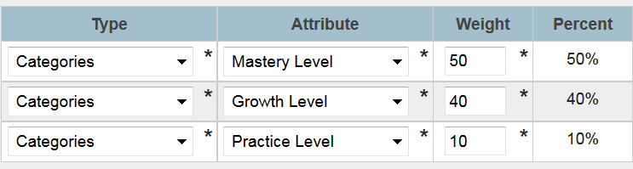

Quarter 2 or Quarter 4

Semester 1 or Semester 2
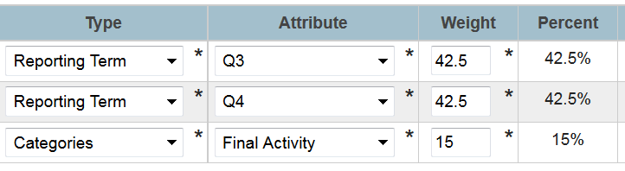
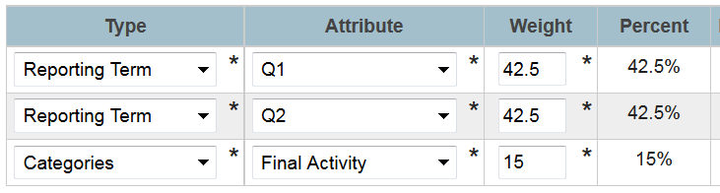

Year-Long Courses:

For year-long courses, a student’s final grade will be calculated using the following procedure:
- Each 9 weeks, or Quarter, will only be based on the three categories listed above (Mastery, Growth, Practice).
- The 1st Semester grade will be an average of the first and second 9 weeks (quarters).
- The 2nd Semester grade will be an average of third and fourth 9 weeks (quarters).
- For the Final Grade, also known as Yearlong, the Final Activity will count 15% and the two semester grades combined will count the remaining 85%.

The calculation in PowerSchool for a high school Year-long course will look as follows:

Quarter 1, Quarter 2, Quarter 3 or Quarter 4

Semester 1
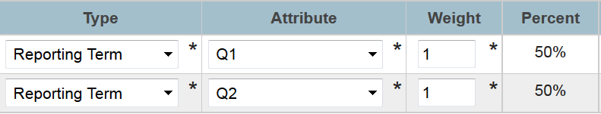

Semester 2
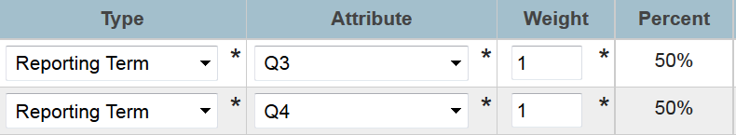

Yearlong
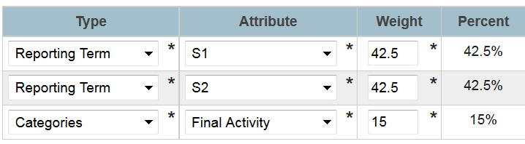

Students may retake the same course when the student wishes to obtain a better grade in a course. The original grade shall appear on the transcript and the retaken course grade shall also appear on the transcript. The higher grade shall be figured into the GPA. Students shall receive credit only once for a single course. The credit earned for the course shall appear on the transcript under the higher course grade.

The Isle of Wight County School’s grading scale will be used for transfer grades (except when the previous school’s grade scale is provided). For regional programs, including The Governor’s School for Science and Technology, The Governor’s School for the Arts, The Pruden Center, and Southeastern Cooperative Education Program, Isle of Wight County Schools will use the letter grade assigned through the program.

Check Point Assessments (CPAs) will may be given throughout the school year. The building administrator will determine the category or how the CPA will be weighted (i.e., no grade, quiz grade, or classwork grade).

Attendance Policy, Promotion and Course Credit

Elementary school students may not be promoted to the next grade if unexcused absences from school total more than ten (10) days.

Middle school students may not be promoted to the next grade nor granted credit for a course if unexcused absences from school or from a class which earns high school credit total more than ten (10) days.

High school students may not be granted credit for a course if unexcused absences from class total more than five (5) class periods for a semester course, or ten (10) class periods for year-long courses.

Appeals Procedure

A parent who has a child who is retained or refused credit for a high school class due to violation of the attendance policy may appeal to the school principal. The appeal must be written, state the reason why the imposed consequences for violation of the attendance policy should be waived, and include the dates of any absences in question.

Within five days of the receipt of the request for a hearing, the principal shall schedule a meeting for the parent with the School Leadership Team. At that meeting, the principal and members of the team shall review the student's attendance and scholastic record, hear the parent present their case, and examine the evidence of extenuating circumstances.

The principal shall issue the parent a written decision within five working days after the hearing. The written decision shall state whether the provisions of the attendance policy will be upheld or waived and state whether the child will be promoted, retained, and/or given credit for a high school class(es). The principal's written decision shall be final.

Attendance Policy and Course Credit

Elementary school students may not be promoted to the next grade if unexcused absences from school total more than ten (10) days.

Middle school students may not be promoted to the next grade nor granted credit for a course if unexcused absences from school or from a class which earns high school credit total more than ten (10) days.

High school students shall not be granted credit for a course if unexcused absences from class total more than five (5) class periods for a semester course, or ten (10) class periods for year long courses.

Appeals Procedure

A parent who has a child who is retained or refused credit for a high school class due to violation of the attendance policy may appeal to the school principal. The appeal must be written, state the reason why the imposed consequences for violation of the attendance policy should be waived, and include the dates of any absences in question.

Within five days of the receipt of the request for a hearing, the principal shall schedule a meeting for the parent with the School Leadership Team. At that meeting, the principal and members of the team shall review the student's attendance and scholastic record, hear the parent present their case, and examine the evidence of extenuating circumstances.

The principal shall issue the parent a written decision within five working days after the hearing. The written decision shall state whether the provisions of the attendance policy will be upheld or waived and state whether the child will be promoted, retained, and/or given credit for a high school class(es). The principal's written decision shall be final.Attendance Policy and Course Credit

Elementary school students may not be promoted to the next grade if unexcused absences from school total more than ten (10) days.

Middle school students may not be promoted to the next grade nor granted credit for a course if unexcused absences from school or from a class which earns high school credit total more than ten (10) days.

High school students shall not be granted credit for a course if unexcused absences from class total more than five (5) class periods for a semester course, or ten (10) class periods for year long courses.

Appeals Procedure

A parent who has a child who is retained or refused credit for a high school class due to violation of the attendance policy may appeal to the school principal. The appeal must be written, state the reason why the imposed consequences for violation of the attendance policy should be waived, and include the dates of any absences in question.

Within five days of the receipt of the request for a hearing, the principal shall schedule a meeting for the parent with the School Leadership Team. At that meeting, the principal and members of the team shall review the student's attendance and scholastic record, hear the parent present their case, and examine the evidence of extenuating circumstances.

The principal shall issue the parent a written decision within five working days after the hearing. The written decision shall state whether the provisions of the attendance policy will be upheld or waived and state whether the child will be promoted, retained, and/or given credit for a high school class(es). The principal's written decision shall be final.Top of Form
Top of Form
Top of Form
Top of Form
Top of Form
Top of Form
Top of Form
Top of Form
Top of Form
Top of Form
Top of Form
Top of Form
Top of Form
Top of Form
Top of Form
Bottom of Form
Bottom of Form
Bottom of Form
Bottom of Form
Bottom of Form
Bottom of Form
Bottom of Form
Bottom of Form
Bottom of Form
Bottom of Form
Bottom of Form
Bottom of Form
Bottom of Form
Bottom of Form
Bottom of Form
Top of Form
Top of Form
Top of Form
Top of Form
Top of Form
Top of Form
Top of Form
Top of Form
Top of Form
Top of Form
Top of Form
Top of Form
Top of Form
Top of Form
Top of Form
Bottom of Form
Bottom of Form
Bottom of Form
Bottom of Form
Bottom of Form
Bottom of Form
Bottom of Form
Bottom of Form
Bottom of Form
Bottom of Form
Bottom of Form
Bottom of Form
Bottom of Form
Bottom of Form
Bottom of Form

Attendance Policy and Course Credit

Elementary school students may not be promoted to the next grade if unexcused absences from school total more than ten (10) days.

Middle school students may not be promoted to the next grade nor granted credit for a course if unexcused absences from school or from a class which earns high school credit total more than ten (10) days.

High school students shall not be granted credit for a course if unexcused absences from class total more than five (5) class periods for a semester course, or ten (10) class periods for year long courses.

Appeals Procedure

A parent who has a child who is retained or refused credit for a high school class due to violation of the attendance policy may appeal to the school principal. The appeal must be written, state the reason why the imposed consequences for violation of the attendance policy should be waived, and include the dates of any absences in question.

Within five days of the receipt of the request for a hearing, the principal shall schedule a meeting for the parent with the School Leadership Team. At that meeting, the principal and members of the team shall review the student's attendance and scholastic record, hear the parent present their case, and examine the evidence of extenuating circumstances.

The principal shall issue the parent a written decision within five working days after the hearing. The written decision shall state whether the provisions of the attendance policy will be upheld or waived and state whether the child will be promoted, retained, and/or given credit for a high school class(es). The principal's written decision shall be final.

Issued: August 11, 1994
Reissued: December 8, 1994
Reissued: January 14, 1999
Reissued: September 8, 2003
Reissued: January 12, 2004
Revised: October 13, 2005
Revised: June 10, 2010
Revised: May 5, 2011
Revised: September 13, 2012
Revised: November 8, 2012
Revised: April 11, 2013
Revised: August 8, 2013
Revised: December 12, 2013
Revised: December 11, 2014
Revised: August 5, 2015
Revised: August 13, 2015
Revised: September 8, 2016
Revised:

